1. Introduction:-
- The main purpose using computerized system is to avoid manual problems and also documentation storage problem we can’t maintain long period data that’s why we used computerized system to overcome all problem related to school’s data storing and other arias.
- This website handles online student admission procedure.
- Hillfort public school is a web based project that maintains all the activity related to school. This project works on dynamic website handling.
- Hillfort project show time to time event information related to school. It also provides the facility for sending mail to parent regarding student activity.
- The proposed website controls student information and faculty details.
- This is web based project it’s provide privilege facility for security purpose and provide login facility according to designation and restrict unauthorized used, if user is not admin then it can’t access everything, this project provide four type of designation facility and access permission.
- We can generate report according to date & show all report also; Because of manual system we faced many problems. The maintenance cost of manual system was very high. And they didn’t store historical information and not possible to view all at a time.
- This web site reduces the time & cost and provides the facility to retrieve student all information according to requirement.
- School event and all activity related information display on this web site, the school related latest news display on this site
- School related all information display on this project.
2. Objective:-
Hill fort public School is web based project that is maintain all the activity related to School, it store all the information of student, Hill Fort Project provide sending mail to parent regarding student activity detail.
Hill fort project show time to time event information related to school, hill fort project provide the facility for suggestion regarding school rules and regulation and student complaint.
- To provide student detailed information and faculty details.
- To make admission procedure fast and easy.
- To inform student with time to time event information and notices.
- To inform parents about student activities through email.
- To generate separate student and faculty login Id and password.

3.1 Feasibility Study:-
A procedure that identifies, describes, and evaluates candidate systems and selects the best system for the job is called as Feasibility study.
Three key considerations are involved in the feasibility analysis:
- Technical Feasibility
- Economic Feasibility
- Operational Feasibility
1. Technical Feasibility:-
The use of CSS and .NET makes form design easy and convenient. The project can be run on any system with minimum requirements. It reduces data entry errors because of data entry validation, it can be easily handled by any user, and it also helps in faster data updations. Also the project though developed in GUI, it is very easy to operate. Hence the project is technically feasible.
2. Economic Feasibility:-
Cost benefit analysis is very important in deciding whether the project is economically feasible or not. It is alone sufficient to save our time and money. It is one time investment and does not require regular maintenance. Through cost benefit analysis it was concluded that the benefits outweigh costs and thus the project is economically feasible.
3. Behavioral Feasibility:-
Behavioral feasibility determines how much effort will go into educating, selling and training the user staff on a candidate system. The project was also evaluated to be behaviorally feasible as it is very user-friendly and hardly needs any extra efforts to educate user for its utility and functioning.
3.2 Present System in use:-
The present system consists of static web pages and do not allow dynamic insertions of data. Hence there is a need to create a dynamic website.

- System can be web-based so that everyone can easily interact with system.
- System can provide optimize functionality.
- System can be customizable so that one can update it.
- System can be flexible enough so that it can incorporate different changes time to time.
- All the information related with HILLFORT PUBLIC SCHOOL can be documented.
- The most important thing is security. All the data should remain consistent and secure.

3.3 Software Requirement Specification: -

School administrator wants to build the system that technically and economically strong and helpful to company progress. He wants to reduce large man-power involved in company to perform the task that high company cost and slow company work. For future use all documents are kept in written or in a file in secure manner. If a file gets lost it cannot be retrieved in any way. A large storing area is required to store the data manually.

The purpose of software requirements specifications is to provide a framework that enables the manager to take reasonable estimates of resources, cost and schedule. These estimates are made with a limited time frame at the beginning of a software project and should be updated regularly as the project progresses. In addition estimates should attempt to define best case and worst case scenarios so that project outcomes can be bounded.

To gather the requirement of client’s need, we take the idea about the data flow from other school websites and also refer documents of school.

3.4 Flaws in present system / Need for new system:-

- Present system is a totally manual system which lacks security and is time consuming. This is not user friendly
- The data is recorded manually, which is error prone and often leads to confusion.
- A lot of file work had to be done for storing information like student details, faculty details.
- There may be possibility of delay in managing whole admission process.
- Also certain information redundancy may occur then it will become a hurdle to manage.
- Staff member Management entitles all management of activities related to notice, time table and result publish and so on requires a lot of paper work.
3.5 Proposed System:-
This site is an attempt to make the task of administrator easier. This project ensures the consistency by enabling the parents to register themselves and to find the desired information about school time table, notices, event schedule and many more.

The administrator has the right to know everything. He has the right to know the details of the student and faculty, has the right to change any information that the website is currently providing.

The administrator can also contact the parents through email to state his child activities. Aim of this project is to provide an environment helpful for administrator, faculty and parents to obtain information. This project is developed after a thorough study of the existing manual system.
3.6 Project Category:-

This is web based project. This project developed for business purpose. It provides the batter facility for student to check all the information related to exam information and study material.

This project provides the user id to student for check online events and notice.
It provides online admission facility and main objective of this project is increase the admission of school and know everyone about the school and it facility.

While using this application Client will get to know the quality of education that is delivering in school. This project developed for hillfort public school.
4.1 Software Engineering Process Model used:
The waterfall model shows a process, where developers are to follow these phases in order:

- Requirements specification (Requirements analysis)
- Software Design
- Integration
- Testing (or Validation)
- Deployment (or Installation)
- Implementation & Maintenance

I. Requirements Specification:

A Software Requirements Specification is a complete description of the behavior of a system to be developed. It includes a set of use cases that describe all the interactions the users will have with the software.

We studied the requirement and specification provided by client & list out all the functional requirement of website that would be implemented from our side. We also suggest client some good functionality like contact import.

II. Software design:

Software design is a process of problem solving and planning for a software solution. After the purpose and specifications of software are determined, software developers will design or employ designers to develop a plan for a solution.

We have divided the project into small modules and plan how we can design and implement the module as per the client expectation. First we have plan a database scheme of project, which would help us to go in correct flow, we have also design the DFD (Data flow design) to implement the website.

III. System integration:
System integration is the bringing together of the component subsystems into one system and ensuring that the subsystems function together as a system. In information technology, systems integration is the process of linking together different computing systems and software applications physically or functionally, to act as a coordinated whole. We have complete knowledge of all interfaces that would include on our website. It includes interfaces between Modules, Database, Server, and between the other system API (Application program interface), which would work with. For a system to be successfully implemented and used, the elements like DB, files/function must be in place and functioning correctly.

IV. Software testing:
Software testing is an investigation conducted to provide stakeholders with information about the quality of the product or service under test. Software testing also provides an objective, independent view of the software to allow the business to appreciate and understand the risks of software implementation. Test techniques include, but are not limited to, the process of executing a program or application with the intent of finding software bugs (errors or other defects).
We have checked the accuracy, completeness, consistency, spelling and accessibility of website. These areas are the first things judged by the user. Users must have the best possible experience with our website. For browser compatibility we have tested the website in all browsers to make sure the graphics and other objects on a website would be displayed same. To check all of these modules, test browsing needs to be done. The purpose of this test is to find flaws in the navigation of the web pages.

V. Software deployment:
Software deployment is all of the activities that make a software system available for use. The general deployment process consists of several interrelated activities with possible transitions between them. These activities can occur at the producer site or at the consumer site or both. Because every software system is unique, the precise processes or procedures within each activity can hardly be defined. Therefore, "deployment" should be interpreted as a general process that has to be customized according to specific requirements or characteristics.
After implementation & testing of whole website on local server, we have deployed the website on main server to get ready for launch. The client has provided their server details along with database details. We transfer (uploaded) files from our local server to the main server through ftp(file transfer protocol), also run the sql file in asp.net file to import the database , then we configure the file for database connection to run the system on main server.
VI. Implementation & Maintenance:
The Maintenance phase is the longest phase of the SDLC. In this phase the software is updated to:
-Fulfill the changing customer need.
-Adapt to accommodate change in the external environment.
-Correct errors and oversights previously undetected in the testing phase.
-Enhance the efficiency of the software.
4.2 Modules and Modular Charts:

Login
Student Login
Student Admission
Notice
Other Activities
START
Already User?
Registered user
Yes

4.3 System Flow Chart:
Hill fort Public School
Student Login

Database
Report
Student Admission
Notice
Other Activities

Create User Account

Student
Admission table

Notice table
Other activity table
5.1 Data Structure, File Design / Table:

Student Admission:-
The student admission table stores the StudentID ,Class, UserType, pwd, NameOfStudent, Sex, DOB, Nationality, Religion, Mothertounge, NameOfFather, Occupation, NameOfMother, Occupation2, Mobile, ResidencePhone, ResidenceAddress, Email, City Country etc.

Notice:-
The Notice table srored the NoticeID, Notice, Date etc.

Other Activity:-
The Other Activity table stored OtherActivityID, OtherActivityName, Date etc.

5.2 Data Flow Diagram:-
A dataflow diagrams shows the functional relationship of values computed by a system, including input values, output values and internal data stores. It is a graphical representation showing the flow of data values, contains processes, data flow, actor objects, and data stores. Data Flow Diagram (DFD) is one of the first tools used to model system components. The components of DFD’s are the system processes, the data used by processes, any external entities that interact with the system and the information flows in the system.

0 levels DFD:

Hillfort
Public
School
User
Server
User Login
Process

Response
Response

Figure: 0 Level DFD
1st level DFD:

Hillfort Public School
Student information

Notice
Other Activity

Student
Reports
Retrieve data

Admission form info
Student Admission
Notice
Other Activity
Generate Report
Notice info
Other Activity info
Save & retrieve student information
Save & retrieve Notice
Save & retrieve other activity

Figure: 1st level DFD
5.3 Entity Relationship Diagram:-

Make
Has
Name Of
Student
Student admission
Student ID
DOB
Class
Name Of
Father
Notice
Notice
NoticeID
Date
Nationality
Mobile
OtherActivityName
Other activity
OtherActivityID
Date

Figure: ERD
5.4 Modularization details:-
In any Company many projects are going on at a particular time. Each project is divided into various modules depending upon the work. Each Module depends upon the work. Each module is depending upon the task it does has got various forms, reports etc.

Student information:
I. Student Admission: Basically it contain whole information of student regarding to student admission form, in this form required information like name, class, gender, user id and password of student and required mandatory field.

II. Notice: this table information hold Notice of School related to Exam, Event etc.

III. Other Activity: this specified the other activity of student like Sports, Events etc.

IV. Time Table: it displays the schedule of exam timing, school timing and class timing.

5.5 Data Dictionary:

Student Admission:

Sr. No | Field name | Data type | Constraints | Description
01 | StudentID | Int | Primary Key | Store student ID
02 | Class | nvarchar(50) | Not null | Store class
03 | UserType | nvarchar(50) | Not null | Store user type
04 | Pwd | nvarchar(50) | Not null | Store password
05 | NameOfStudent | nvarchar(50) | Not null | Store student name
06 | Sex | nvarchar(50) | Not null | Store sex
07 | DOB | datetime | Not null | Store date of birth
08 | Nationality | nvarchar(50) | Not null | Store nationality
09 | Religion | nvarchar(50) | Not null | Store religion
10 | Mothertounge | nvarchar(50) | Not null | Store mothertounge
11 | NameOfFather | nvarchar(50) | Not null | Store name of father
12 | Occupation | nvarchar(50) | Not null | Store occupation
13 | NameOfMother | nvarchar(50) | Not null | Store name of mother
14 | Occupation2 | nvarchar(50) | Not null | Store occupation2
15 | Mobile | nvarchar(50) | Not null | Store mobile no.
16 | ResidencePhone | nvarchar(50) | Not null | Store residence phone
17 | ResidenceAddress | nvarchar(50) | Not null | Store residence address
18 | Email | nvarchar(50) | Not null | Store email
19 | City | nvarchar(50) | Not null | Store city name
20 | Country | nvarchar(50) | Not null | Store country

Notice:

Sr. No | Field name | Data type | Constraints | Description
01 | NoticeID | Int | Primary Key | Sotre notice ID
02 | Notice | nvarchar(MAX) | Not null | Store notice
03 | Date | datetime | Not null | Store notice date

Other Activity:

Sr. No | Field name | Data type | Constraints | Description
01 | OtherActivityID | Int | Primary Key | Store other activity ID
02 | OtherActivityName | nvarchar(MAX) | Not null | Store activity name
03 | Date | datetime | Not null | Store activity date

5.6 Form Design

Home page:


Login form: Student login

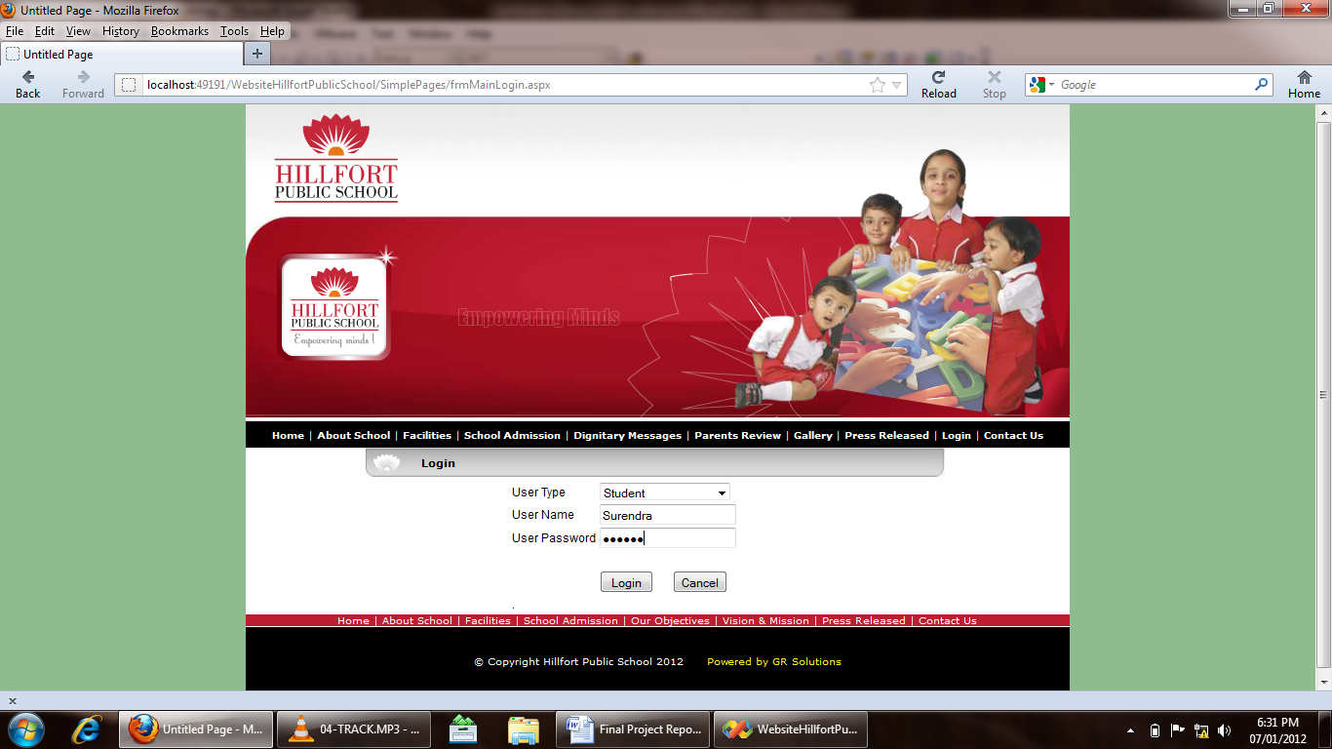

Login Account:

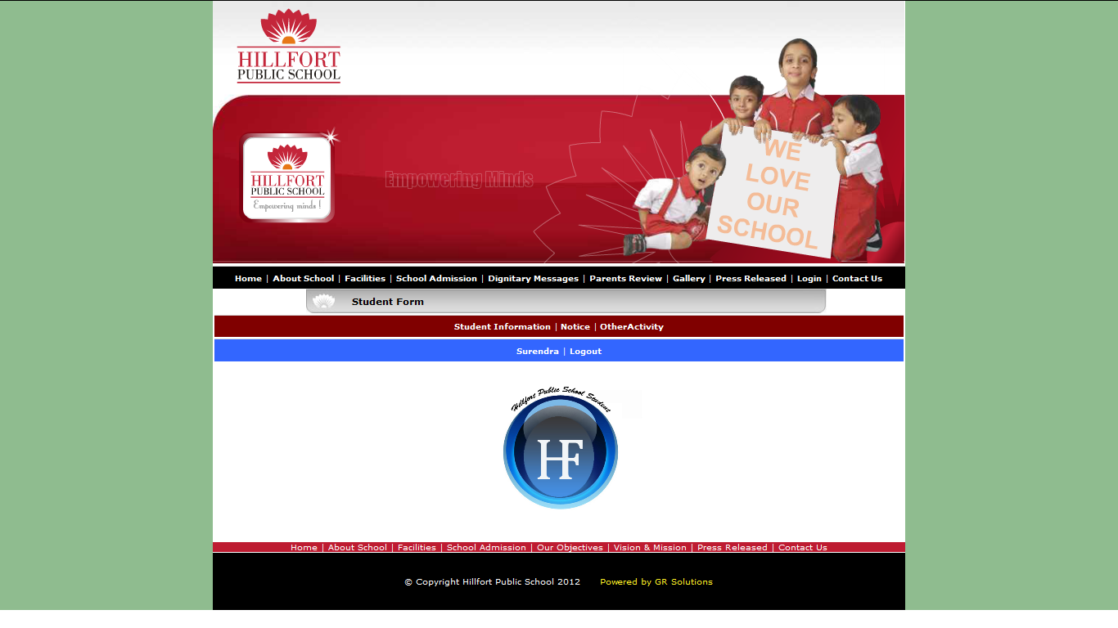

School Admission: Input Screen

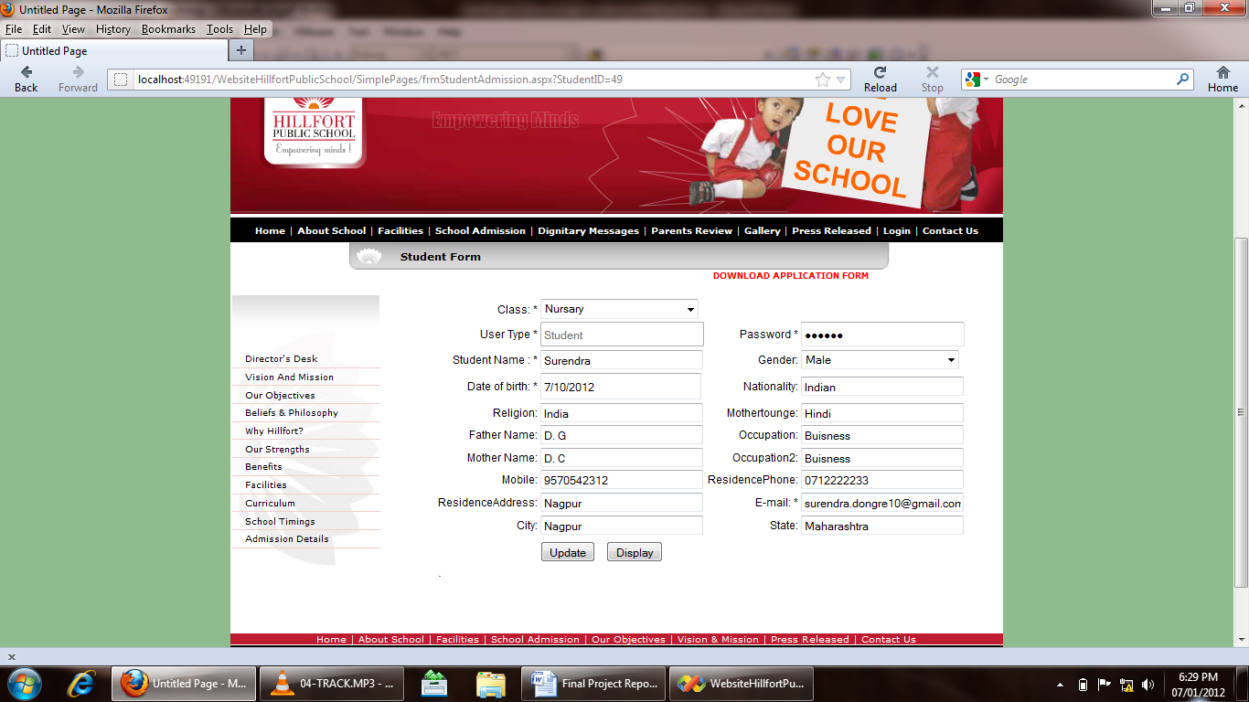

Output Screen:

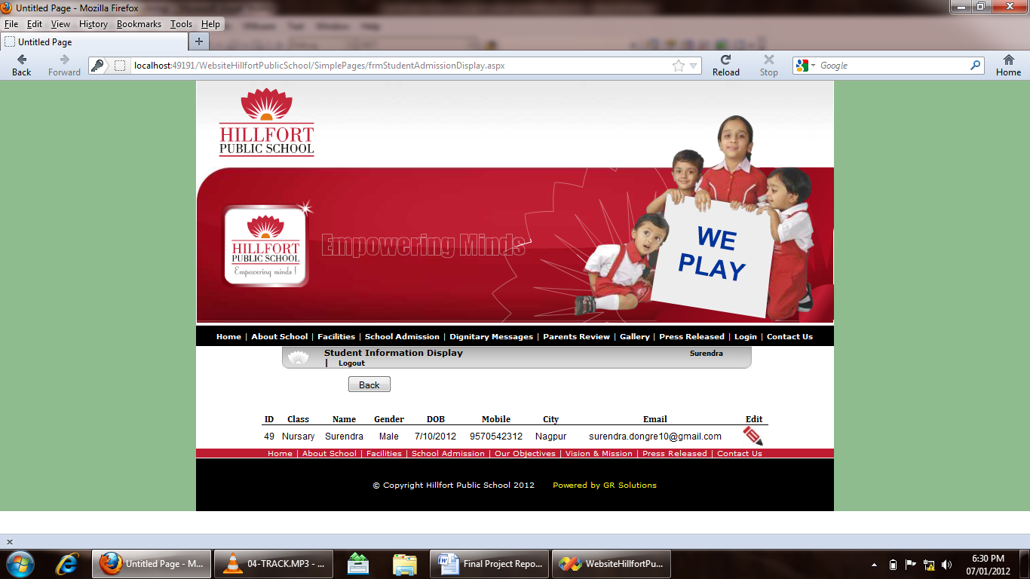

Notice:

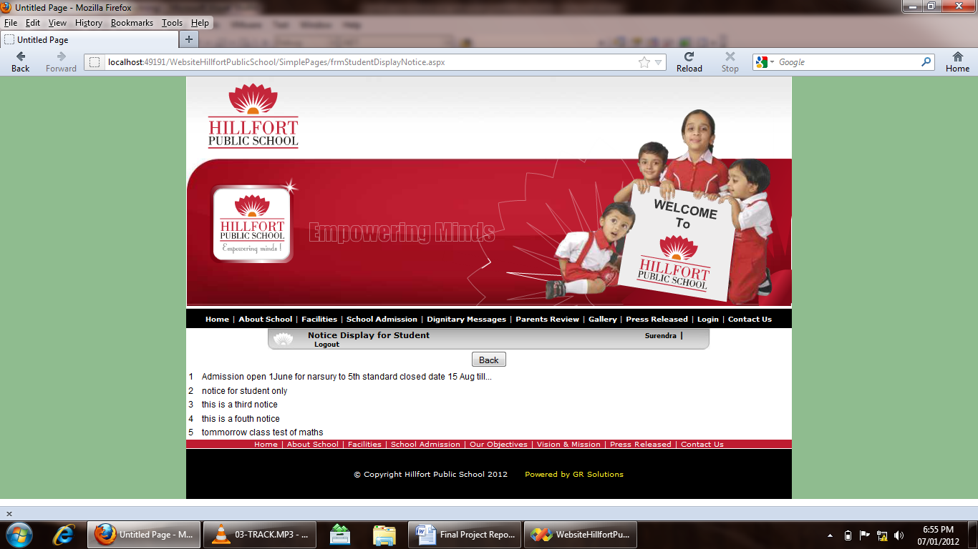

Other Activity:

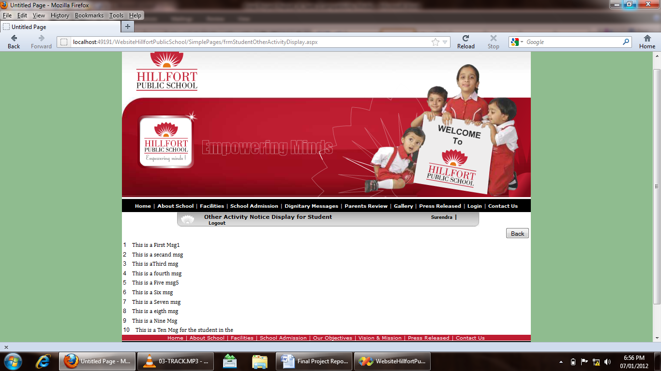

Logout:

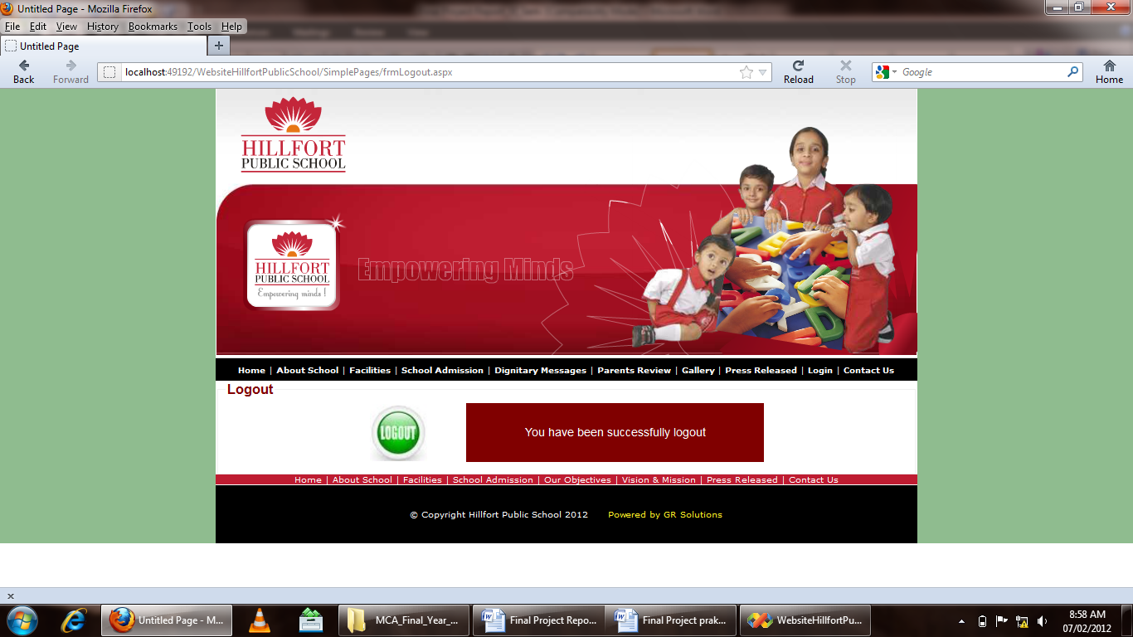
6. Validation Checks:
Under validation we have provided certain constraints and primary keys to few fields of the tables of the database used in application. This validation made at database level is listed below:

- Required Field Validation: we use require field for fill the information compulsory in the project without this validation the data will not be submitted in the project.

- Not null: Not null constraint is used restrict field to have null values. Few fields in our database are mandatory to fill.

- Numeric only: Numeric only constraints restrict field to have numeric values only. Otherwise it violates the rule.

- Character only: It restricts the field to accept only character value.

- Date: The valid date with valid format should be enter in the given textbox.

- Email: The @ Symbol is required in this field otherwise it will not work properly.

7. Implementation:-
Domain Names: Based on requirement, we will need to pick out a Domain Name. While a domain name that uses words that summarize the site or services are good for school administrator, which help us in deciding the domain name and getting it registered.
Hosting: We have to take a space on server for our files so the website would be access through internet.

I. Site Category & Layout:
The message to get across to the viewer quickly and easily. We have take the time to determine what’s the main theme or message is to be, then break that theme or message down into categories. Which will help guide us through this process and help determine a site format that loads

II. The Size Website:
Normally it’s best to keep our first website to a minimum size. Not only is it less costly, but this allows administrator to grow as the web base clientele increases. We add, change and substitute new information, pages, links, and text as the business and site progresses. Starting with a basic website leaves the room to grow and change as the circumstance dictates.
8. Testing:
There are various types of web application testing without which we cannot say that the complete system is properly working. Some of the most important web testing has been mentioned below:
Unit Testing: Unit testing happens at the development level. When a developer builds a piece of code that delivers a set of functionality, they must test it to make sure it works and that it delivers the required functionality. A developer tests by running the code in their own environment. A piece of code (be it a web page or a function) should never go into a systems integration environment until it has been unit tested.

System integration testing (SIT): A systems integration environment is a test environment where code (web pages, classes, databases) is placed to ensure the application as a whole works together. Usually there’s more than one developer building an application or site. Each one unit tests their individual functions and pages, and one a regular basis, their code is deployed into the SIT environment and tested together. This ensures one developer’s code doesn’t break the others. Usually test cases and test scripts are developed based on the functional requirements and tested here. It provides a more integrated view of the application. This is also the environment that gives a mirror of the production environment. Most applications live with other applications in production. This is the first chance to ensure that the new application/site doesn’t break and isn’t broken by other sites or applications in the same environment.

No. | Test case Title | Description | Expected Outcome | Result
1 | Successful start up of the application and the login menu being present to take the user to login prompt | The menu is clicked | The login prompt should come up | Passed
2 | Select the user type | Select the appropriate user type i.e. administrator, faculty and student | Ask for username and password | Passed
3 | Registration of Admin | Click on the login button. | The appropriate admin panel will appear | Passed
4 | Update user information | Click edit button | The update page should come with user information | Passed
5 | Delete User | Click delete button | Message should come “whether you want to delete user” and after clicking yes user should be deleted | Passed

Table: Testing table
9. Evaluation:-
Evolution processes are multi-level, multi-loop, multi-agent feedback systems. This phase is basically based on the client what they want to update in the software. In the project evaluation the main thing is how the project will work in the client-side or server-side, and how much better performance in the system. The project is web based application so it will be do proper work in the client side and properly interact with the hardware.
Steps to Evaluate
- Install the software on a clean system.
- Check for proper operation of software.
- Check for .dll file conflicts.
- Check for registry entry problems.
- Check for file conflicts.
- Create Application item.
- Push application to test station and check for proper operation.
After performing all the above steps it is justified as project has been implemented successfully.

10. Security Measure Taken:-
To understand what measures are taken for security of application, first we need to understand what kind of threats penetrates the security of application. Errors and omission, disgruntled and dishonest employees, external attacks and natural disasters.
.
i) Authentication:-
System checks the password under the particular user identification. The computer permits the various resources to the authorized person.

ii) Authorization:-
The access control mechanism to prevent unauthorized logging to the system.

iii) Form authentication
The Form authentication collects user's credential and lets the application use own logic to authenticate users. The collected user's credential is validated using the list maintained by the application. The application maintains its own user list either using <credential> element in the web.config file or using database. The advantage of using form authentication is that the users don't need to be the member of windows network to have access to the application.
11. PERT Chart and Gantt chart: - The purpose of controlling a project is to monitor the progress of the activities against the plans, in order to ensure that the goals are being approached and, eventually, will be achieved. Another aspect of control is to detect, as soon as possible, when deviations from the plan are occurring, so that corrective action may be taken. There are following tools used for the project control:
      - PERT chart
      - Gantt chart

I. PERT chart: - PERT (Program Evaluation & Review Technique) chart is a network of boxes (or circles) and arrows. There are different variations of PERT charts. Some use the boxes to represent activities and some use the arrows to do so. Each box thus represents an activity. Arrows are used to show the dependencies of activities on one another. The activity at the head of an arrow cannot start until the activity at the tail of the arrow is finished.

25 April-15 May april
15 May- 25 May
1 Mar-20 Mar
20 Mar-25 April
24 Jan-5 Feb
6 Feb-28 Feb
18 May
Final Review
Start
Testing
Integration
Implementation & Maintenance
Software Design
Requirements specification
Deployment

Figure: PERT Chart
II. Gantt chart: - Gantt charts are developed by Henry L. Gantt. Gantt chart is project control technique that can be used for several purposes, including scheduling, budgeting, and resource planning. A Gantt chart is a bar chart, with each bar representing an activity. The bars are drawn against a timeline. The length of each bar is proportional to the length of time planned for the activity.

 |  | Month
No. | Task | Jan | Feb | Mar | Apr | May
01 | Requirements specification (Requirements analysis)
02 | Software Design
03 | Integration
04 | Testing (or Validation)
05 | Deployment (or Installation)
06 | Implementation & Maintenance
07 | Final Review

Figure: Gantt chart
12. Future scope of the project:-

- Presently the website is used for primary school students but in future it can be utilized for middle school, high school and colleges by some minor modifications.
- Database may be available in future for long times and information may be use anytime.
- SMS facility in future

13. Conclusion:
The conclusion of “HILLFORT PUBLIC SCHOOL” is to construct such dynamic website which will provide information about school activities such as admission system, event schedule, school time-table, important notices and dignitary messages.

Towards the end of the Hill fort Public School project, I would like to say that the target, which was initially set up, was achieved to a good extent. The project made me realise the significance of developing software for client, where the sole aim is to learn.

During the Hill fort Public School project, the real importance for following all principle of system analysis and design dawned on me. I felt the necessity of going through the several stages.

As we done the initial investigation, now we can say that this application possible to create. But as project will progress there may some change in functionality of the project.

14. Bibliography:
Following books are referred for developing this project:

- “ASP.NET COMPLETE REFERENCE”, MCGRAW-HILL EBOOKS
By HERBERT SCHILDT

- “SOFTWARE ENGINEERING”, SIXTH EDITION, TATA MC GRAW HILL
By ROGER S. PRESSMAN

- “DATABASE SYSTEM CONCEPTS”, FIFTH EDITION, TATA MC GRAW HILL
By HENRY F. KORTH

- SYSTEM ANALYSIS AND DESIGN
By ALIAS M. AWAD

Website visited:

- www.msdn.microsoft.com
- www.projectcode.com
- www.plus2net.com/sql_tutoria
- www.W3Schools.com for CSS Tutorials
- http://forums.asp.net

